Alaska: Weather and Wildlife throughout the Parks

T.J. Ossola

Spencer Davis

Joey Riebel

Erich Mitchell

Our motivation for this project is our general love for the great outdoors. Part of having a great trip is planning. We are providing a planning resource to help potential tourists to Alaskan state parks to use as a planning tool. Users will be able to search for different biodiversity within the 15 parks within our data set. Users will also be able to check out local weather to the parks for packing planning, and when the best time to visit is based on weather preferences.

We chose MongoDB as the way to navigate through our datasets. MongoDB allows data to be stored in JSON style dictionaries and allows for more variability in the data structure and quicker reading of the data. We were planning on using the national parks service website to pull data but the website was down so we adjusted where we pulled our dataset. We were able to pull 15 separate parks wildlife data in csv format and used the park code as the primary key:

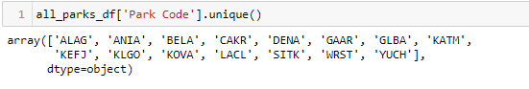

We got the data from the following websites:

Nat Parks BioDiv 4 years ago

https://www.kaggle.com/nationalparkservice/park-biodiversity

Nat Parks BioDiv current

https://irma.nps.gov/NPSpecies/Search/SpeciesList

Need to search park for data

Openweather api

"http://api.openweathermap.org/data/2.5/weather?"

Each excel doc was parsed out in a clean format, and we focused on the ‘common name’,’occurrence’, and ‘abundance’. There was a slight difference between some of the datasets between the keywords ‘occurrence’ and ‘abundance’ so added both in to ensure the record was added to the dictionary.

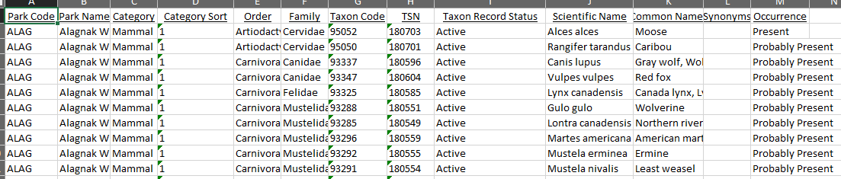

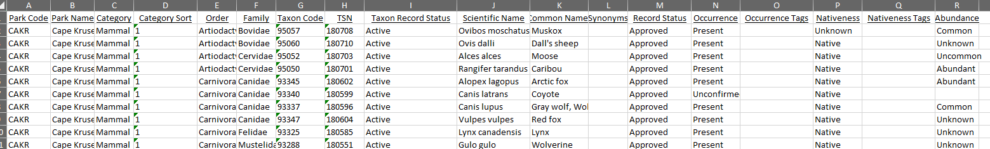

We read all the excel files into a single database to query.

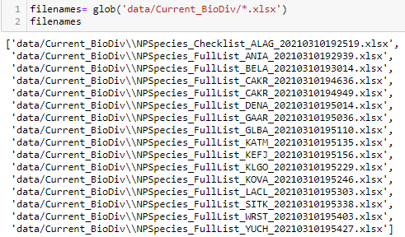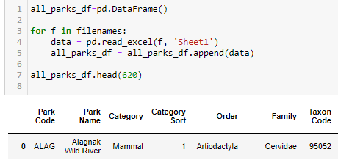

We created a for loop to loop through each park code based on the category, then added the common name, occurrence, and abundance to lists to create a dictionary.

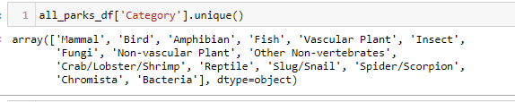

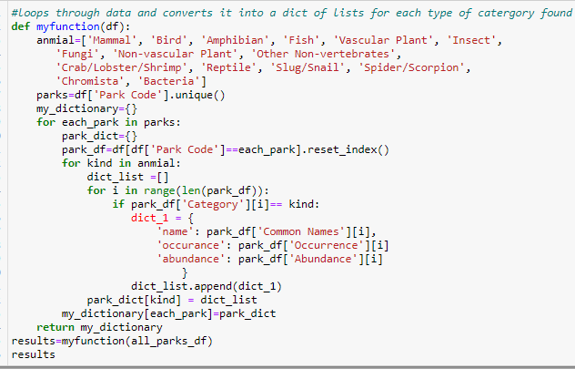

We decided to use an open weather API to get weather data surrounding the parks. We reached out to a Park Scientist in Alaska and found out that most of the weather stations are outside the parks themselves. We then pulled the weather data for the city that park is in, or the closest city.

Use’ cases for the data we pulled would likely be for vacation planning. This will help tourists research what kinds of wildlife and vegetation is active in the different parks around Alaska. For example, where would they want to go if they wanted to see wolves, etc. Users will be able to look up weather conditions for trip planning to have the greatest chance for optimal weather conditions on their trip.